**D.JEEVAN KUMAR**

**196Q1A0532**

**3RD YEAR – CSE**

# ASSIGNMENT 1

Q1) 1. In the below elements which of them are values or an expression? Eg :- values can be integer or string and expressions will be mathematical operators.*-Expression 'hello' -Value-87.8 -Value--Expression/-Expression+Expression6-Value

Q2) a string is a value representing text a variable is a name that can refer to any value quotes, double or single, (they mean the same, but can’t be matched with each other) are used to create string literals, the quotes are there to indicate that the text that they enclose is not code, it is a value.

Q3) List: the list is used for storing multiple data items in a single variable.

Integer: integer can store only numerical values.

Float: float can store only floating values such as 233.33, 22.2, etc.

Q4) Expression is made up of values, containers, and mathematical operators

(operands) e.g

a = 2 + 3 and expressions are used to evaluate the values or represent the result on the screen.

Q5) Expression is made up of values, containers, and mathematical operators (operands) and the statement is just like a command that a python interpreter executes like print. Q6) bacon = 22 bacon + 1

Sol: it gives 23 as execution code

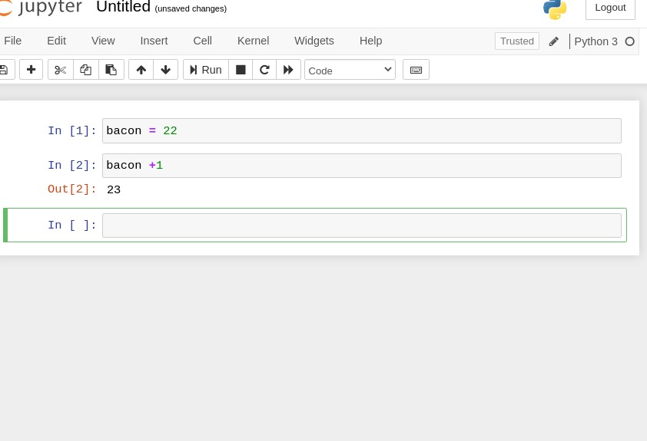

Q7) spam' + 'spamspam'

'spam' * 3 sol: it will be the same

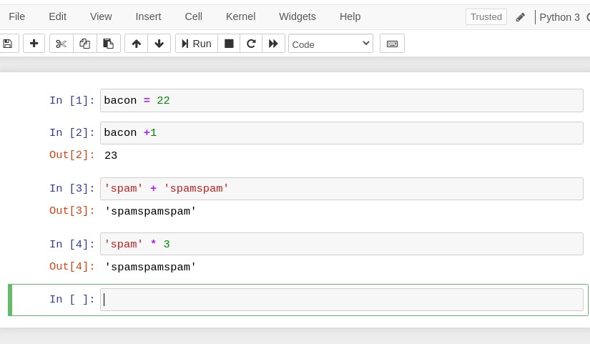

Q8) because we can't start giving variable an integer name. if we, we should begin with, a string-like alphabet name then integer. e100 or eggs100 is valid.

Q9) str(), int(), float()

Q10) because 99 is an integer it cannot be concatenated with strings, if we have to concatenate it we need to do typecasting.